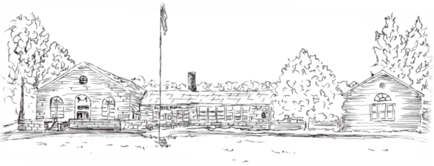
OXFORD CENTER SCHOOL
462 Oxford Road, Oxford CT 06478
Telephone: (203) 888-6492
Fax: (203) 881-5212

www.oxfordpublicschools.org

Heath Hendershot, Principal
Dear Parents and Families,

In keeping with past school traditions, the 4th grade class will be celebrating Thanksgiving by having a feast on Friday, November 16, 2018. The students will be provided with delicacies that commemorate this exciting period in our nation’s history.

The meal will include turkey, mashed potatoes, homemade stuffing, gravy, cranberry sauce, and corn for the price of $7.00 per student. The meal is peanut and tree nut free. You may also request a dairy, egg, gluten and/or meat free meal, which has been done in the past. Please contact Mrs. Elken with any specific questions regarding allergies at elkenh@oxfordpublicschools.org.

If you would like your child to participate in the feast, please fill out the form and return it by Wednesday, November 7, 2018.

Contact Aaron Reich with any questions at reicha@oxfordpublicschools.org.

Sincerely,

The 4th grade team

Student’s Name___________________________________________________________

_____Yes, I would like my child to participate in the Thanksgiving Feast. The $7.00 is enclosed. No checks, please.

_____No, I would not like my child to participate in the Thanksgiving Feast.

Parent’s Signature_________________________________________________________

